Dental Pain Relief Treatments Effects Study

Xinyi Zhang

**Background**

An anesthesiologist studied the effects of acupuncture and codeine on postoperative dental pain in male subjects. In this study, there are four treatments being tested:

* A1B1 – placebo treatment (a sugar capsule and two inactive acupuncture points)
* A2B1 – codeine treatment (a codeine capsule and two inactive acupuncture points)
* A1B2 – acupuncture treatment (a sugar capsule and two active acupuncture points)
* A2B2 – codeine and acupuncture treatment (a codeine capsule and two active acupuncture points)

**Randomized Block Design Model**

Thirty-two male subjects were selected and grouped into eight blocks of four, based on initial evaluation of their pain tolerance level. In each block, four treatments described above were randomly assigned to four subjects. Then, the data for relief scores are recorded – higher score means the treatment is more effective.

**Why Blocking Is Done**

In our randomized block model, pain tolerance was used as the blocking variable. This is because people rated with lower pain tolerance may be more sensitive to postoperative dental pain. Vice versa, higher tolerance level means this person is more tolerant to postoperative dental pain. Different tolerance levels among experimental subjects may greatly affect experimental outcomes, as subjects receiving the same treatment can give very different results due to their pain tolerance. With the randomized block design, we are guaranteed to get fair comparisons of four treatments with respect to each block.

**Dataset**

We use following code to read the dataset and name the data object as “pain”. Then, we name columns as “Y”, “Block”, “A”, “B”. We print out the first six rows of “pain”, which agrees with the original dataset.

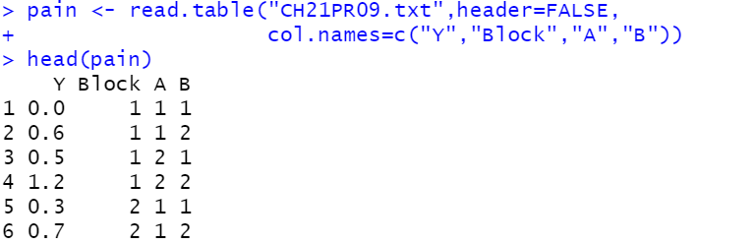

Then, we use the following code to set up factors in our randomized block model. The first factor is treatment (Trt), which contains four levels as described in the background. We randomly assign four treatments to eight blocks and add “Trt” to our data set.



Then, we make “Block” as another factor with total of eight levels. This is done by the following code:



We obtain our new “pain” dataset, after factors were created and treatments were randomly assigned.

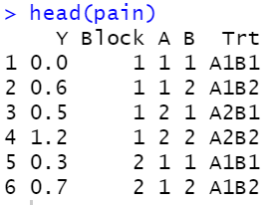

**Model and Concerned Assumptions**

The purpose of this analysis is to check whether assumptions about the randomized block model are satisfied. In this study, we will ignore the possible factorial structure of treatments.

The model equation we will use is $Y_{ij}= μ_{..}+ ρ_{i}+ τ_{j}+ ϵ_{ij}$.

In this model, $ρ_{i}$ are constants for the block effects and $τ_{j}$ are constants for the treatment effects.

Assumptions to Consider:

1. $ϵ_{ij}$: independent, normally distributed, with mean 0 and constant variance $σ^{2}$.
2. There is no treatment-block interaction effect.

**ANOVA Table**

The code below fits the data to the additive two-way model and the ANOVA table is shown as followed. The additive two-way model we assumed here is $Y_{ij}= μ_{..}+ ρ_{i}+ τ_{j}+ ϵ_{ij}$. As mentioned above, $ϵ_{ij}$ are assumed to be independent, normally distributed, with mean 0 and constant variance $σ^{2}$

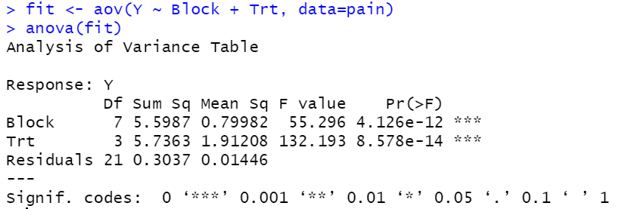

However, we do need to check whether error assumptions and additivity are appropriate in the randomized block model. This will be done in the following analysis.

**Error Assumptions**

We use the following plot function to obtain the plot of residuals vs. fitted values. Fitted values represent the average change in each of the three weight loss programs. The plot is shown below on the left.



Next, we use the R code below to plot the graph of standardized residuals vs. theoretical quantiles. The plot is shown below on the right.



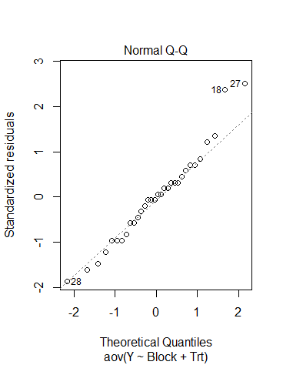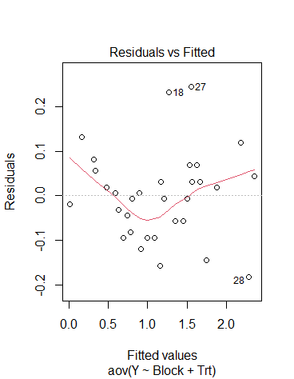

From the first plot, we observe that there is a non-linear relationship between fitted values and residuals. The plot shows that residuals for each fitted value are not evenly distributed above and below the mean 0. Thus, there exists unequal variances among residuals. The relationship between residuals and fitted values seem to have a quadratic appearance. We are not sure about whether the additive mode still holds for the original response variable Y. Further analysis for additivity is needed.

The second plot is the quantile-quantile plot, which compares the theoretical data under normal distribution against the real data. From the plot, we observe that the standardized residuals closely line up with the normal (theoretical) values, only with a few outliers. Therefore, the normal distribution assumption on error terms is satisfied.

**Interaction Plot**

The following code provides an interaction plot for pain relief scores, given four treatments within each block. Eight blocks are visualized by eight colors.

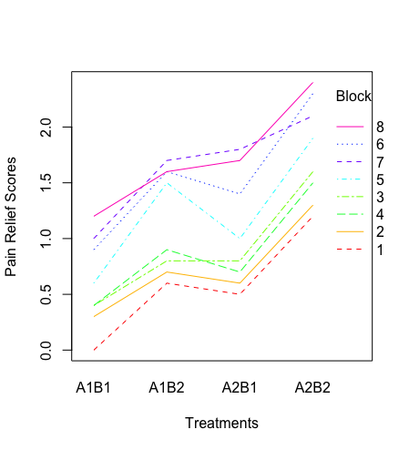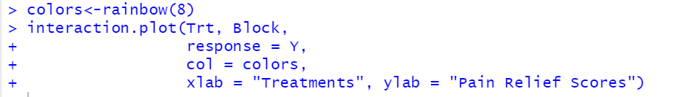

The interaction plot shows that there are many variations between blocks and treatments since we do not observe any paralleled line. But most variations are unimportant interactions, since response lines are closely lined up and share the same trend. Among all blocks, A2B2 treatment has the highest pain relief score and A1B1 has the lowest. In block 6, 7, and 8, there are two intersections when receiving A2B2 treatments. In block 3 and 4, there is one intersection when receiving A2B1 treatment. However, these interactions may appear due to chance since response curves do not seem to deviate too much from the overall trend. We need to conduct a formal test procedure to examine if there is any significant and important interaction between treatments and block.

**Tukey’s 1 df test**

In this problem, we have already observed a quadratic appearance in the plot of residuals vs. fitted values. We suppose that the additive model does not hold for the original response Y but does hold for a nonlinear transformation of Y like $\sqrt{Y}$.

*Claim:*

In this situation, the plot of residuals vs. fitted values from the additive model will have a quadratic appearance.

*Argument:*

For $Y^{'}=aY+bY^{2}$, we have $E\left(Y^{'}\right)=μ_{..}+ρ_{i}+τ_{j}+ϵ_{ij}=E\left(aY+bY^{2}\right)$, so the plot of residuals for $E\left(Y\right)=μ_{..}+ρ_{i}+τ_{j}+ϵ_{ij}$ will have a quadrative shape.

We use Tukey’s 1 df test to conduct a formal test for transformable nonadditivity.

*Hypothesis:*

**H0: There is no transformable nonadditivity**

**Ha: There is transformable nonadditivity**

*Test Procedures:*

Step 1. Calculate the residuals of “fit”. “Fit” represents fitted values derived from fitting the two-way model to Y.



Step 2. Square fitted values and call it qij



Step 3. Fit the additive two-way model to the qij, and we get its residuals as qij.e



Step 4. Let P be the sum of products of the two sets of residuals and Q be the sum of squares of the residuals qij.e

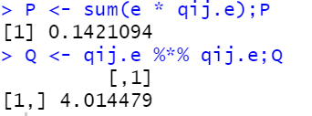

Step 5. Form the sum of squares for transformable nonadditivity having one degree of freedom

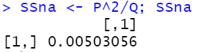

Step 6. Let SSrem = SSE – SSna. SSrem has degrees of freedom (nb – 1)(r – 1) – 1 = 7 * 3 – 1 = 20

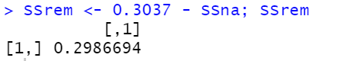

Step 7. Get the F ratio using $F_{na}=\frac{{SS}_{na}}{{SS}_{rem}/(n_{b}\left(r\right)-n_{b}-r)}$ and find the p-value

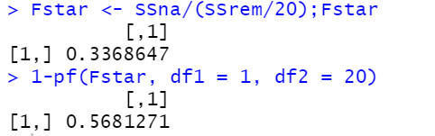

*Null Distribution and Decision Rule:*

The test statistic is $F_{na}=\frac{{SS}_{na}}{{SS}_{rem}/(n_{b}\left(r\right)-n_{b}-r)}$ and has null distribution of F1, 20. We will reject H0 if F > 8.096 under 0.01 significance level, as calculated by the code below.



*Conclusion:*

F = 0.337 < 8.096. Thus, we fail to reject the null. We can conclude that there is no transformable nonadditivity, and no block-treatment interaction effects are present. The p-value for this test is 0.568. Therefore, the additive model assumption is satisfied.

**Analysis of Treatment Effects**

Here we obtain the 99% family-wise confidence interval for all pairwise comparisons of treatment effects. We apply the Tukey procedure, and we obtain:

$SE\left(\hat{L}\right)=\sqrt{MSBL.TR\left(\frac{1}{n_{b}}+ \frac{1}{n_{b}}\right)}= \sqrt{\frac{2MSBL.TR}{n_{b}}}=\sqrt{2*\frac{0.01446}{8}}=0.0601$

$Critical Constant for Tukey studentized range distribution is T=$ 3.5255, as calculated using the R code below



Hence the margin of error is 0.0601 * 3.526 = 0.2119

Mean response of each treatment is calculated using the code below.

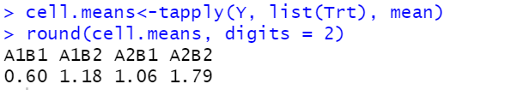

We label four treatments using 1, 2, 3, 4:

A1B1 $μ_{.1}=0.6$ A1B2 $μ_{.2 }=1.18$ A2B1 $μ_{.3}=1.06$ A2B2 $μ_{.4}$ = 1.79

Then, we create the following table to represent the 99% confidence interval of all contrasts.

*Table. 99% Confidence Interval By Tukey’s Method*

|  |  |  |  |  |  |
| --- | --- | --- | --- | --- | --- |
| Contrast | Parameter | Estimate | Margin of Error | Lower | Upper |
| $$L_{1}$$ | $$μ_{.2}- μ_{.1}$$ | 0.58 | 0.2119 | 0.3681 | 0.7919 |
| $$L_{2}$$ | $$μ_{.3}- μ_{.1}$$ | 0.46 | 0.2119 | 0.2481 | 0.6719 |
| $$L_{3}$$ | $$μ_{.4}-μ_{.1}$$ | 1.19 | 0.2119 | 0.9781 | 1.4019 |
| $$L_{4}$$ | $$μ_{.2}-μ_{.3}$$ | 0.12 | 0.2119 | -0.0919 | 0.3319 |
| $$L_{5}$$ | $$μ_{.4}-μ_{.2}$$ | 0.61 | 0.2119 | 0.3981 | 0.8219 |
| $$L_{6}$$ | $$μ_{.4}-μ_{.3}$$ | 0.73 | 0.2119 | 0.5181 | 0.9419 |

To conclude, we are 99% confident that all these CIs above contain their respective parameters. Only the contrast for $μ_{.2}-μ_{.3}$ is not statistically significant, since it contains 0. Other contrasts are all statistically significant. This means that there is no significant difference in effects between using Codeine and Acupuncture separately.

For visualization purpose, we changed the label of treatment factor to 1, 2, 3, 4 accordingly. Then, we fit the new factor to the ANOVA table and used TukeyHSD function to get the 99% family-wise interval.





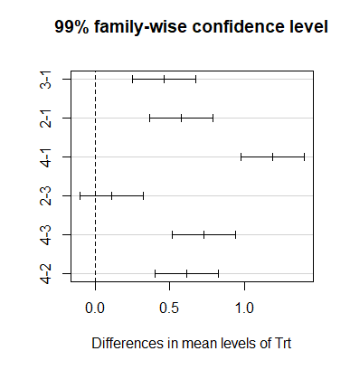

**Reference**

Kutner, M. H., Nachtsheim, C., Neter, J., & Li, W. (2005). Applied linear statistical models.